Bharati Vidyapeeth (Deemed to be University), India
New Law College, Pune
Bharati Vidyapeeth (Deemed to Be University) Pune, New Law College Newlawcollege Pune organized “Regional Conclave on Justice Education in Asia” in virtual mode on 12th – 13th January 2024 which was funded by Regional Committee-Global Alliance for Justice Education (GAJE). The conclave had participants, presenters, and moderators from the Asian Region in particular from Japan, Singapore, China, Philippines, Sri Lanka, Vietnam, Bhutan, Myanmar, Maldives, Mongolia, India, Bangladesh, Pakistan, Nepal, Afghanistan, Kazakhstan, Iran, Iraq, Malaysia, Indonesia and Thailand. Countries from other regions that participated were the USA, Poland, Italy, and Costa Rica. The conclave was marked by panel discussions, deliberations, and a presentation on the status of justice education in Asia bringing out the initiatives and the challenges that exist. The deliberations and discussions were fruitful and recommendations will be sent to the Global Alliance for Justice Education. The organizing and networking committee consisted of Prof. Dr. Ujwala Bendale, Dr. Seyed Masoud Noori, Dr. Sharin Naomi, Ms. Ujjwala Sakhalkar and Dr. Rohit Surawase.
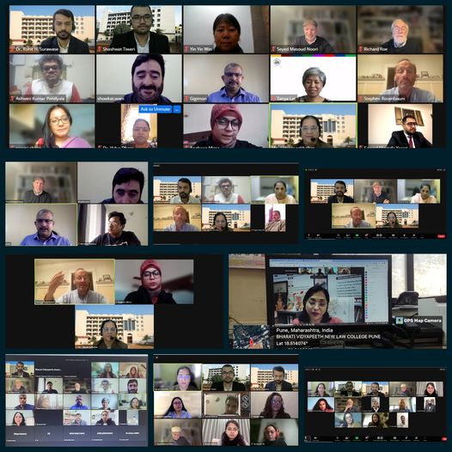

ONE DAY WORKSHOP ON “CONSUMER PROTECTION LAWS”
Center for Community Development through Law, organized a One Day Workshop on “Consumer Protection Laws” on 9th September, 2023 which was held on virtual mode. The workshop was inaugurated at the hands of Hon’ble Justice Shri. Ambadas H. Joshi, Former Judge, Bombay High Court, Mumbai Lokayukta, Goa. The workshop covered topics like Evolution Of Consumer Movement In India – An Overview, Significance Of Consumer Protection Act 2019 – Paradigm Shift, Judicial Approach And Rights Of Consumers – Indian Perspective, and Suggestions For Amendment In Consumer Protection Act 2019 – Legislative Framework. Across the courses offered by New Law College 277 students and faculty participated in the event. Hon’ble Justice Shri. Makrand S. Karnik, Judge, Bombay High Court, Mumbai was chief guest of the valedictory function. The expertise was drawn from Academicians, Advocates and Legal luminaries. Ms. Ujjwala Sakhalkar, Dr. Rohit Surawase and Mr. Umesh Jawalikar were the convener for the workshop.
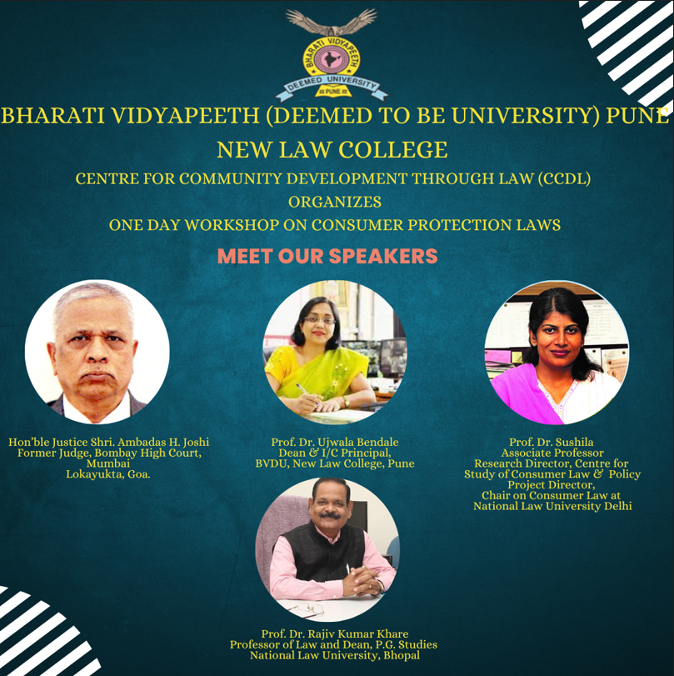

THE CENTER FOR COMMUNITY DEVELPOMENT THROUGH LAW – CCDL
TEN- DAYS LECTURE SERIES ON “GENDER, LAW AND EQUALITY: EMERGING ISSUES”
Center for Community Development through Law, organized “Ten days lecture series on Gender Law and Equality: Emerging Issues” from 4th to 14th September 2023. The present lecture series is organized to explore how gender influences legal doctrine. It also focussed on how law in a number of specific areas of law affects women and shapes societal understandings of gender. The Lecture series also proved to be effective educational program that equipped students to utilize the frameworks of various disciplines in order to analyse women, gender and sexuality in meaningful ways.
The lecture series covered gender specific topics like- Introduction to Gender Justice: Notion and Significance, International And Constitutional Perspectives on Gender Equality, Gender Violence: Within and Beyond, Mental Health and Gender Equality, Using Gender Neutral/Inclusive Language In Law, Gender Equality In Marriage And Family, Gender Justice & Work Place Security, Religion, Culture and Gender Equality, Law Of Torts and Gender Equality and Property Laws and Gender Equality. Across all the courses offered by New Law College 137 students and faculty participated in the event. The expertise was drawn from Academicians, Advocates and Legal luminaries. Ms. Ujjwala Sakhalkar, Dr. Rohit Surawase and Ms. Akanksha Ghatol were the convener for the lecture series.
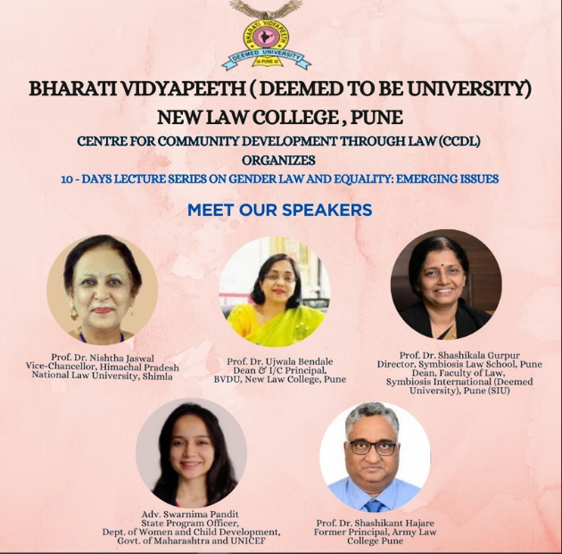
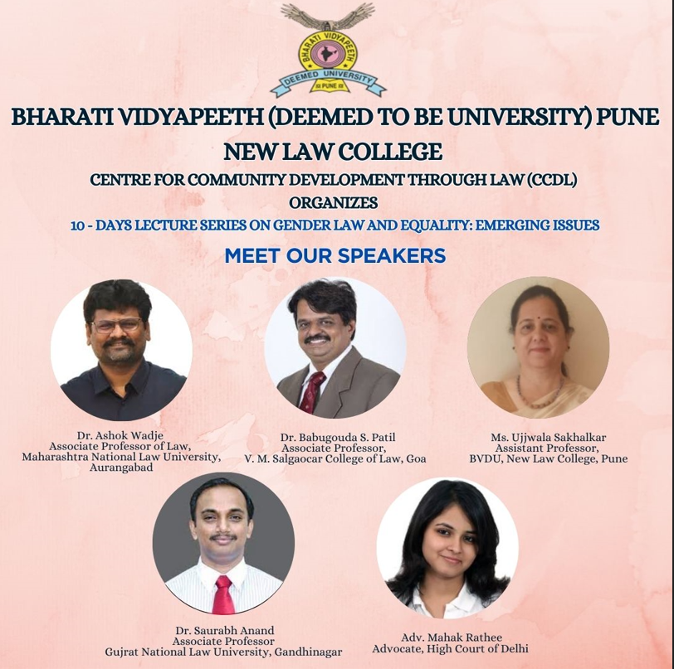

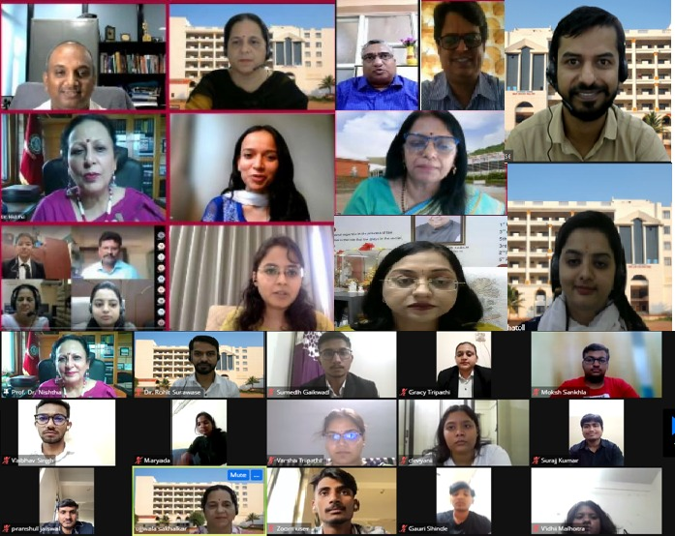

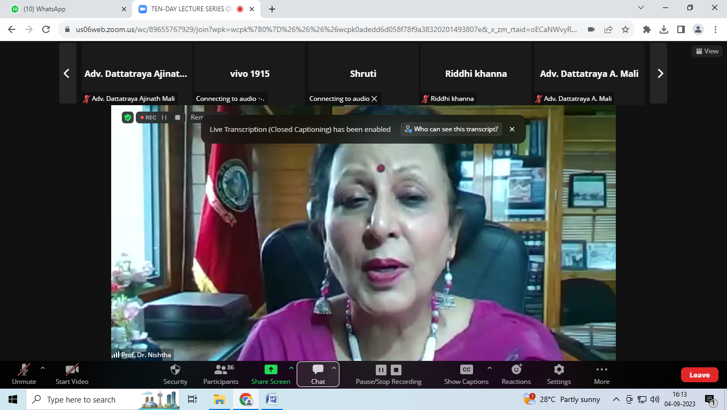

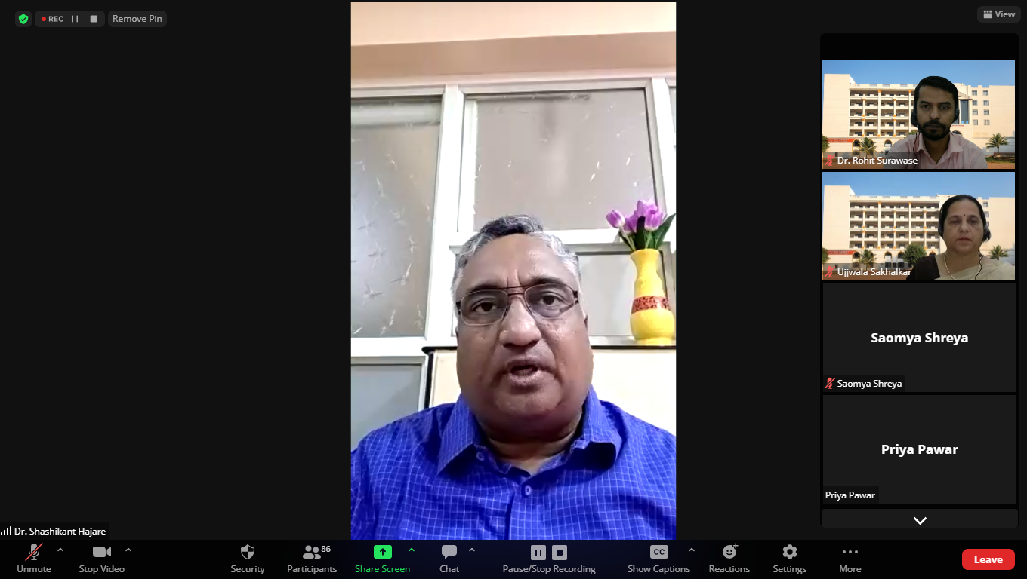

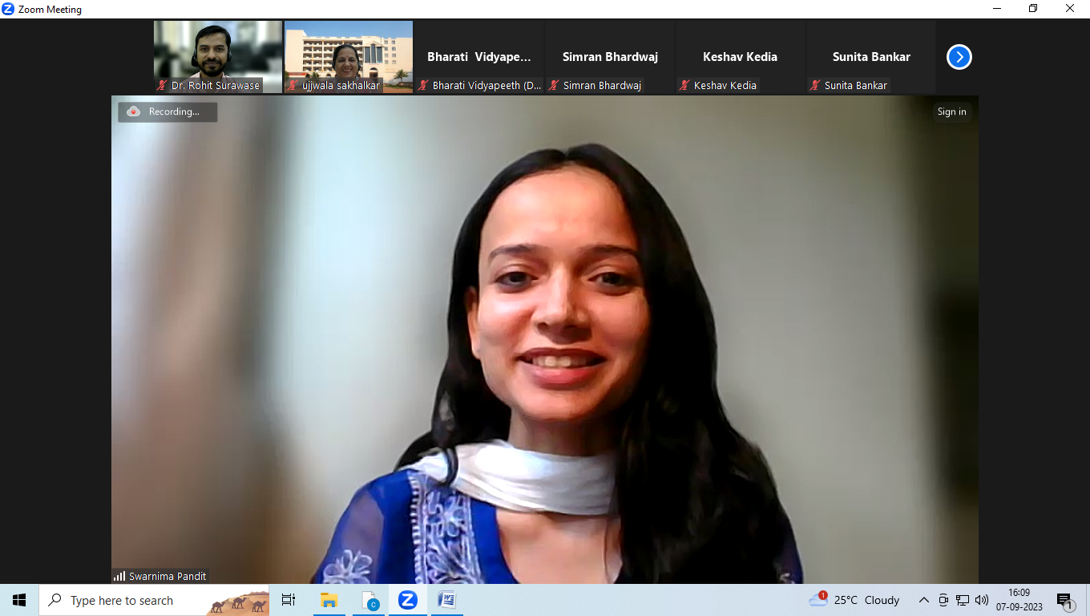

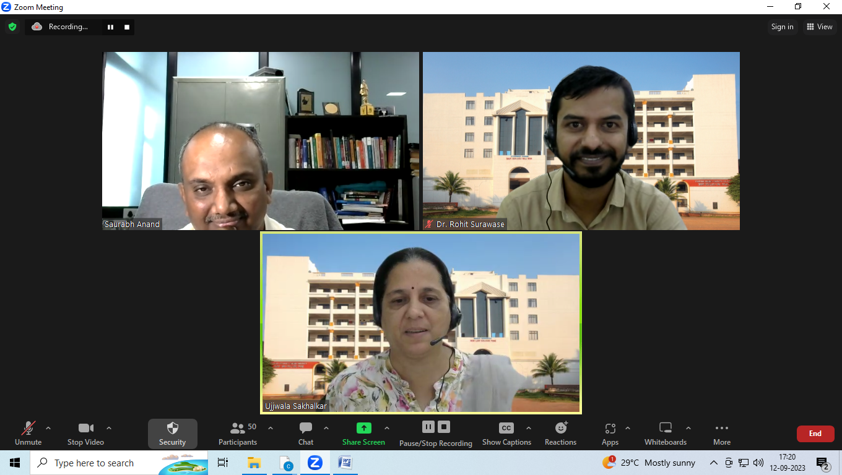

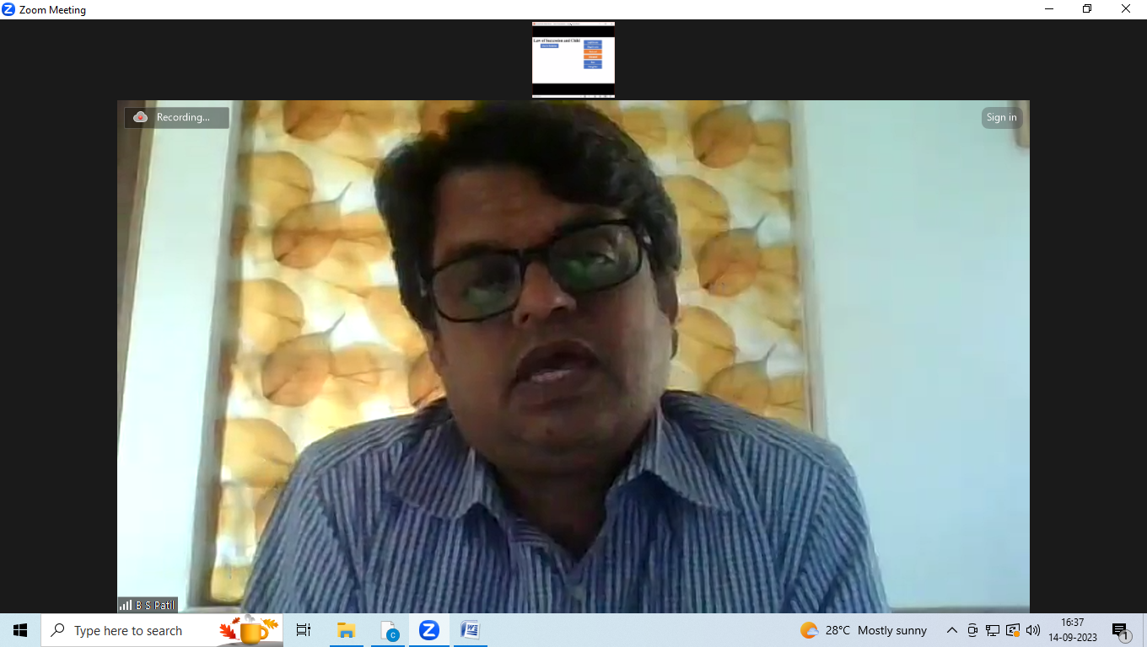

Regional Conclave on Justice Education in Asia
Building Network for Social Justice
Funded by Regional Committee-Global Alliance for Justice Education
27th - 28th September 2022
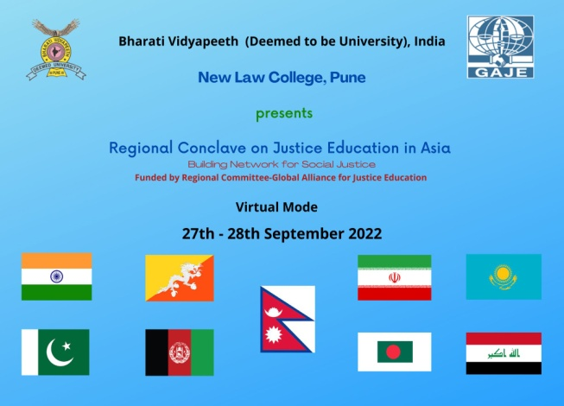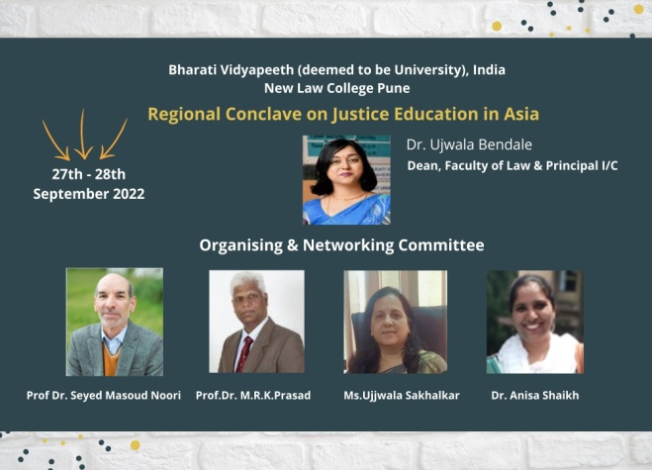
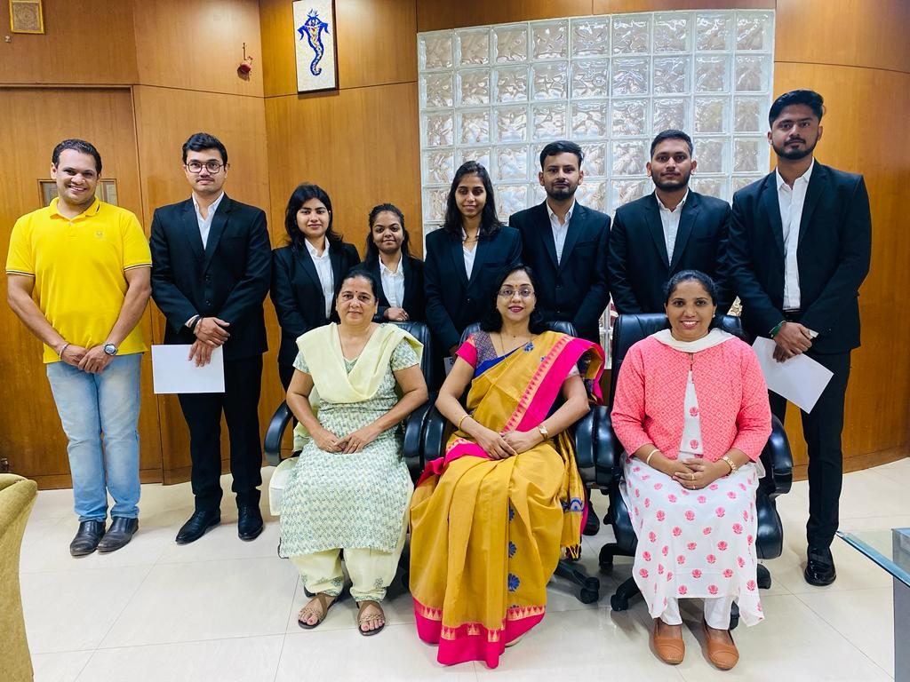

Regional Conclave on Justice Education in Asia was conducted on 27th and 28th September 2022 funded by Regional Committee-Global Alliance for Justice Education (GAJE). The conclave had attendees, speakers, panelists, moderators, presenters and institution representatives from India, Bangladesh, Bhutan, Pakistan, Nepal, Afghanistan, Kazakhstan, Iran and Iraq.
The conclave spread over two days with expertise sharing, panel discussion, presentations from law schools, justice educators and United Nations Office on Drugs and Crime (UNODC). There were 9 speakers for opening and closing session, 54 attendees, 5 panelist, 8 moderators, 3 institution representatives and 20 presenters of 16 law schools.
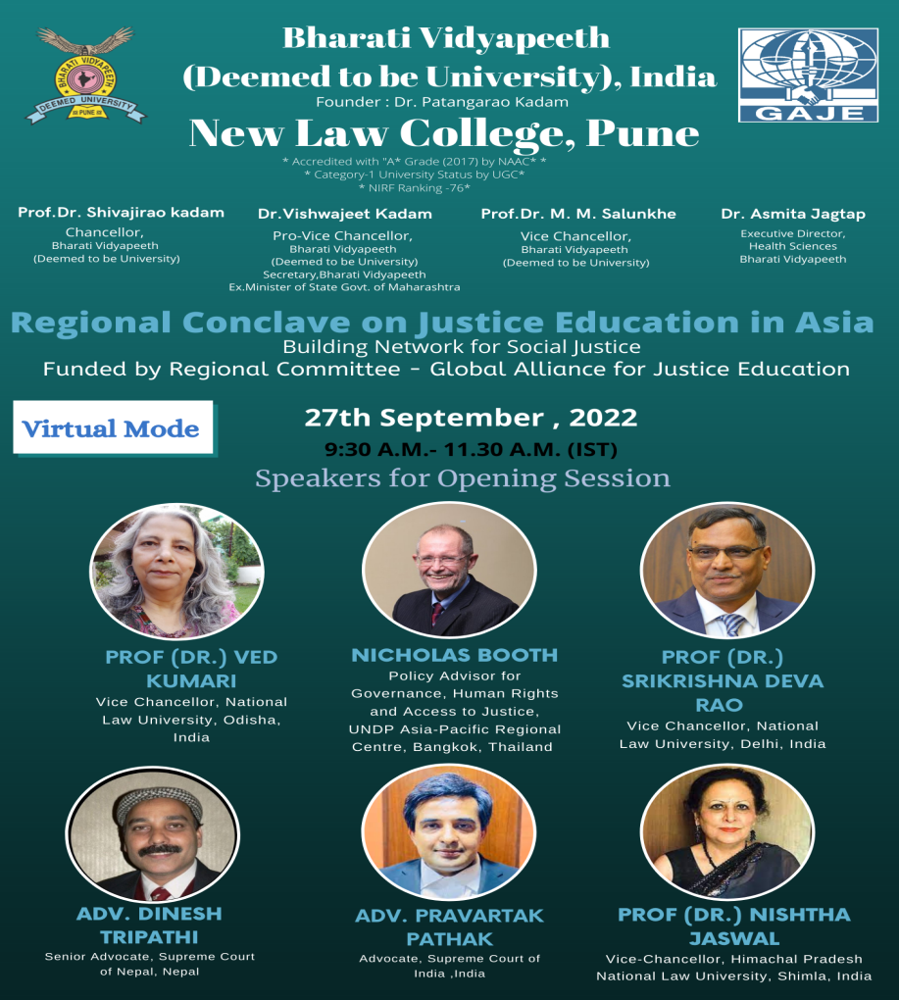
DAY 1- 27th September 2022
SESSION I - 9.30 A.M.- 11.30 A.M. (IST)
The Inspiration and Diversification of justice Education: an Overview

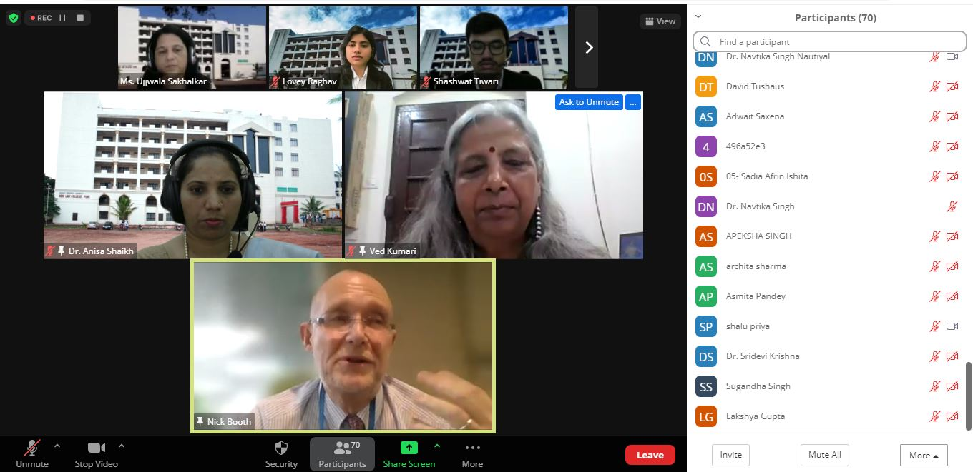

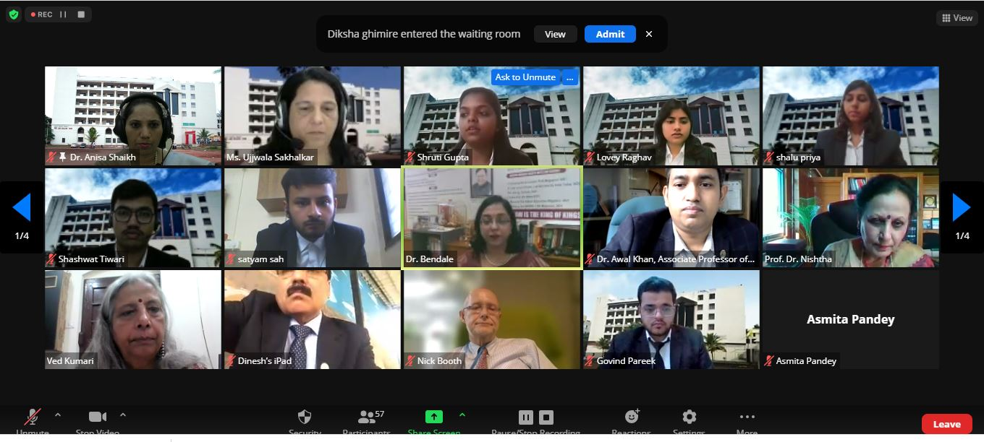

SESSION II, 11:45 A.M- 12:45 P.M.(IST)
Justice Education in Asia: Initiatives, Challenges the Roadmap
Moderators: Prof (Dr) MRK Prasad Student Co-ordinator: Shruti Gupta & Shalu Priya
Panelists | Designation
Adv. Zoha Savadkouhifar | Advocate and Legal Advisor, Pakistan
Dr. Kalpeshkumar L Gupta | Assistant Professor, Gujarat National Law University, Gandhinagar, India
Dr. Md. Abdul Awal Khan | Associate Professor  Department of Law & Additional Director, IQAC  Independent University, Bangladesh
Ms. Alida Binte Saqi | Lecturer, Department of Law and Human Rights,  University of Asia Pacific, Bangladesh

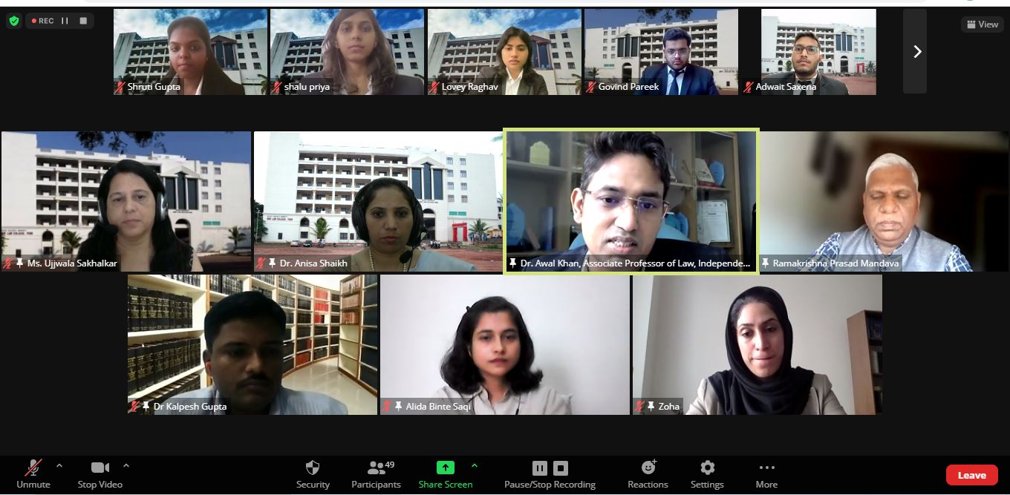

SESSION III, 1:30 P.M.- 3:45 P.M. (IST)
Best Teaching Methods, Innovative Ideas for Social Justice : Law Colleges Initiative
Moderators : Dr. Masum Billah & Adv Avantika Sanyal
Student Co-ordinator: Satyam Sah, Govind Pareek, Adwait Saxena & Shashank Raj
Presenters | Designation/Country
Dr. Kuntirani Padhan | Asst.Professor,  National Law University Odisha, India
Adv. Naeemeh Abbasian | Legal advisor and Researcher, Tehran, Iran
Adv. Ahmed Ehsanul Kabir | Barrister-at-Law (Lincoln’s Inn, UK), Bangladesh
Dema Lham  David W. Tushaus, M.U.R.P., J.D. | Assistant Professor, Director of the Human Dignity Clinic, Child Justice Working Group Member and Technical Reference Group Member for mapping the Justice for Children Workforce, Jigme Singye Wangchuck School of Law, Bhutan  Associate Dean of Graduate and  Experiential Education  Jigme Singye Wangchuck School of Law  Paro, Bhutan
Dr. Shaila Daware  Dr. Suvarna Nilakh | LL.M Department, ILS Law College, Pune, India  Assistant Professor, ILS Law College, Pune, India
Adv. Vijay Prasad Jayshwal | Assistant Professor of Law, Faculty of Law ( Tribhuvan University), Nepal
Prof. (Dr.) Nuzhat Parveen Khan  Mr. Saurabh Sood | Professor and Dean of, School of Law, Bennett University, India  Assistant Professor  School of Law, Bennett University, India
Dr. Bharti Yadav | Assistant Professor  National Law University Delhi

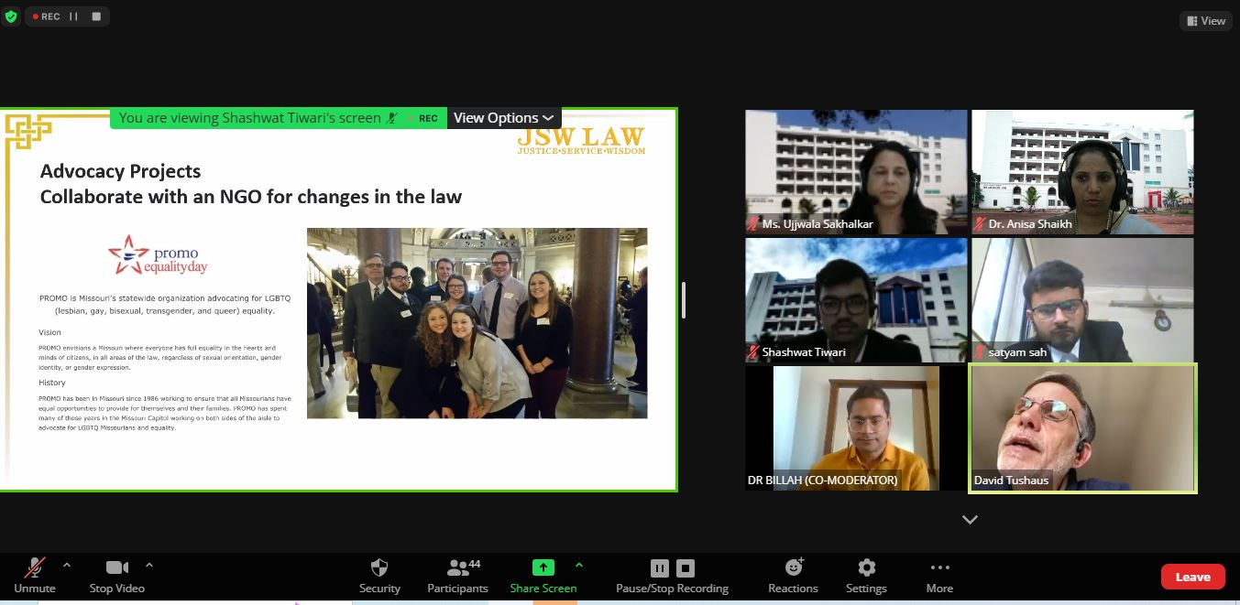

DAY 2: 28th September 2022, TIME : 9:30 A.M. – 11:45 A.M. (IST)
SESSION V
Best Teaching Methods, Innovative Ideas for Social Justice : Law Colleges Initiative
Moderators: Dr. Zahra Azhar & Prof Hugh McFaul
Student Co-ordinator: Yashita Bagwani, Anantika Gurung, Lovey Raghav, Shashwat Tiwari & Shashwat Diwedi

Dr. Kalpeshkumar L Gupta | Associate Professor of Law at Parul University, Vadodara  Founder - ProBono India.  Chief Administrator - Court Management, Law Teachers India
Mr. Seyed Ali Hosseini | PhD Candidate in Global Governance, Balsillie School of International Affairs.Afghanistan.
Zoha Savadkouhifar | Advocate and Legal Advisor, Pakistan
Dr. Shirish Kulkarni,  Dr. Ashish Deshpande, Prof. Yogesh Dharangutti,  Prof. Sangramjeet Chavan | Community Legal Care and Literacy Cell, Symbiosis Law School (SLS), Pune, India.
Elaheh Mogharrabi | Volunteer for legal services at Shahid Beheshti Law Clinic for Females & Family Attached to Research Center of UNESCO Chair on Human Rights, Peace & Democracy
Dr. Tarkesh Molia  Dr. Navtika Singh Nautiyal  Ms. Mradul Singh | Associate Professor, School of Law, Forensic Justice and Policy Studies (SLFJPS), National Forensic Sciences University(NFSU), Gandhinagar, Gujarat, India  Assistant Professor, SLFJPS, NFSU, Gandhinagar, Gujarat, India.  Teaching and Research Associate, SLFJPS, NFSU, Gandhinagar, Gujarat, India.
Advocate Navaraj Pudasaini | Human Rights Lawyer, Supreme Court of Nepal.  Consultant (Part Time) with UNDP on SDG Sub-Platform on Responsible Supplies.
Fatemeh Azizmohammadi  Hajar Salimi Khaligh | Assistant Professor, University of science and culture

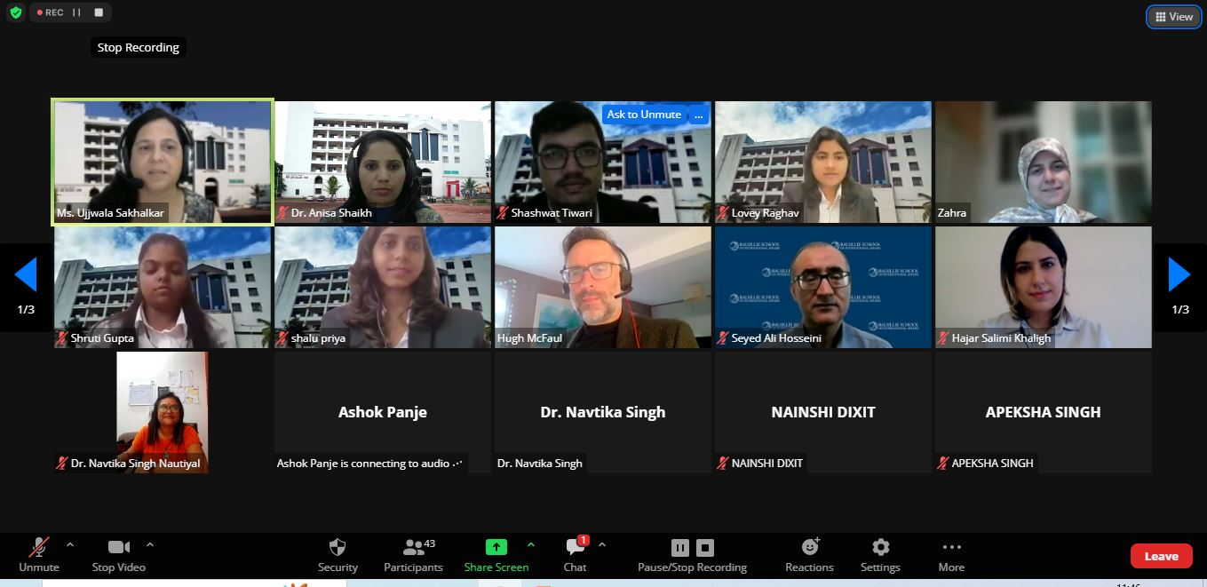

SESSION VI, TIME: 12:00 P.M-1:30 P.M. (IST)
Policy Reflections on Justice Education- Institution’s Initiative
Moderators: Ms. Leni Widi and Dr. Bharti Yadav
Student Co-ordinator: Yashita bagwani, Shalu Priya, Shruti Gupta, Priyansh Shrivastava

Speakers | Institution/ Country
Mr. Alex Petkov  Mr.Samarth Pathak | CommunicationsOfficer  United Nations Office On Drugs And Crimes, Regional Office for South Asia.
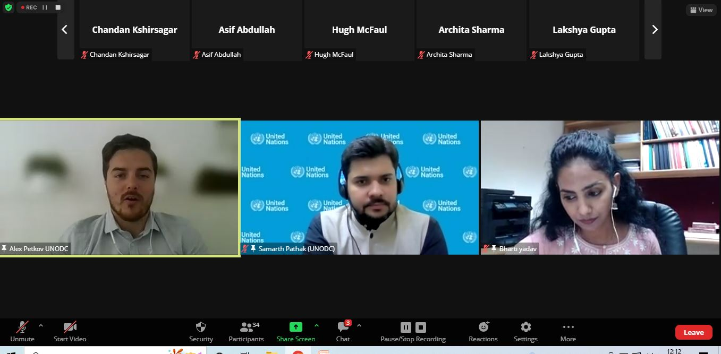

SESSION VII – CLOSING SESSION, 2:40 P.M.-3:40 P.M. IST
Cross-cultural Lawyering and Practices for Imparting Justice Education

Speakers | Institution/ Country
Prof (Dr.) Shashikala Gurpur | Director, Symbiosis Law School, Pune. Dean, Faculty of Law, Symbiosis International (Deemed University), Pune (SIU), India.
Adv. Nirmal Kumar Upreti | Advocate,  President, Forum for Nation Building, Nepal.  Joint-Secretary, NGO Federation Kathmandu Branch  Executive Member, National Network for Safe Migration (NNSM)  Partner, Justice Concern Law Firm  Founding President, Nepalese Law Students' Association (NeLSA), Nepal.
Bruce Lasky | Partner and Pro Bono Head Of Lanna Lawyers.  Co-Founder/Co-Director of Bridges Across Borders Southeast Asia Community Legal Education Initiative

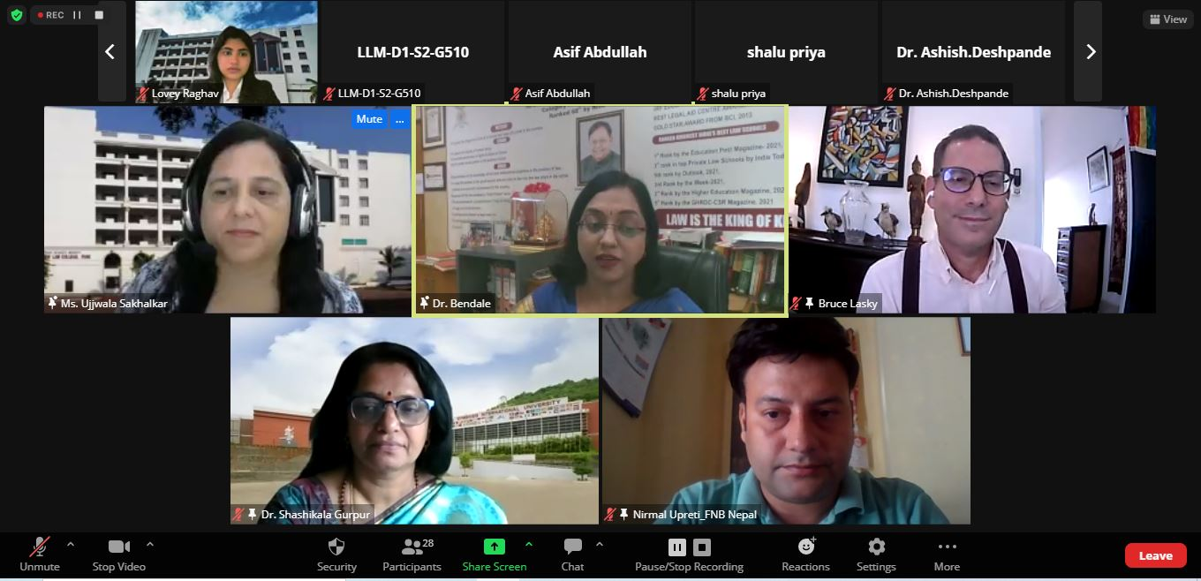

Bharati Vidyapeeth Deemed to be University
NEW LAW COLLEGE PUNE
"A+" Accreditation (Third Cycle) by 'NAAC' in 2017
"A" GRADE UNIVERSITY STATUS BY MINISTRY OF HRD
63rd Rank among Universities by NIRF-2020

“UNHCR Initiatives to Protect Human Rights of Refugees and Displaced People during Covid Pandemic”
New Law College, Pune, Center for Community Development through Law (CCDL) organized a talk on “UNHCR Initiatives to Protect Human Rights of Refugees and Displaced People during Covid Pandemic” on 30th November 2021 at 3.00 p.m. IST. Dr. Ujwala Bendale, Dean & Principal, New Law College, Pune brief the audience about the University, New Law College and CCDL. Ms. Ujjwala Sakhalkar introduced the guest and gave opening remarks. Ms. Kritika Shrivastava, Associate RSD officer, UNHCR, India, was the speaker for the programme. She discussed mandate of the UNHCR and focused on various innovative initiatives taken by UNHCR during Covid Pandemic. Action based strategies were adopted with reference to Primary and secondary health services and stepped-up IDP approach during covid 19. There major work involves Cash assistance, shelter and core relief items, Water, sanitation and hygiene. Digital Support was given in remote areas for online education. Dr. Anisa Shaikh, proposed a vote of thanks.

“COLLOQUIUM SERIES ON PROBONO”
“Probono and Quality Access to Justice for the Disempowered.”

Center for Community Development through Law (CCDL) and Clinical Programmes, Jindal Global Law School, O. P. Jindal Global University jointly organized, the first of its “COLLOQUIUM SERIES ON PROBONO” on 25th Oct 2021 at 7.00 p.m. (IST). The subject of discussion was “Probono and Quality Access to Justice for the Disempowered.” We had presenter from Pennsylvania, USA, Nepal, Indonesia & Nigeria. Prof. Ajay Pandey, Executive Director, Clinical Programmes, Jindal Global Law School represented O. P. Jindal Global University . Susan Lori Brooks, Associate Dean & Professor at Thomas R. Kline School of Law, Philadelphia, Pennsylvania, Martin Geer, Cinical and Practice skills department, Fulbright Specialist, 2022, University of Qatar Doha, Navaraj Pudasaini, Human Rights Lawyer, Nepal, Leni Widi Mulyani, Street Law Clinician/Lecturer, Pasundan University, Bandung, Indonesia and Sam Erugo, Professor of Law, Senior Advocate, Nigeria gave an overview of pro bono work in their respective countries, shared experiences and methodology they use while engaging in pro bono work.

“Interaction with community: understanding cross culture values”
20th October 2021
Bharati Vidyapeeth, New Law College, Center for Community Development through Law-CCDL organized Program on “Interaction with community: understanding cross culture values” in collaboration with Bahujan Hitay Pune (Maitree Network) under Community Fair Project on 20th Oct. 2021 at Dapodi. Ms. Ujjwala Sakhalkar Dr. Anisa Shaikh faculty coordinators of Center for Community Development through Law-CCDL and Mr. Sidhant Kondharwar were present for the programme. Ms. Ujjwala Sakhalkar has highlighted her opinion on Sexual Harassment at workplace. She has also expressed her views on Domestic Violence and other rights of women. Dr. Anisa Shaikh has expressed her views on problems relating to maintenance in society when the case is pending in the court. She specifically spoke about women’s right relating to Maintenance. Mr. Sidhant Kondharwar highlighted the problems relating to use of technology and crime related to it. He focused on cyber law and related issues.

REPORT
Legal awareness Program
23rd July 2021

Bharati Vidyapeeth, New Law College, Center for Community Development through Law-CCDL organized ‘Legal awareness Program’ in collaboration with District Legal Authority Pune, Bahujan Hitay Pune and International Association of Lions Clubs( District 3234-D2) on 23rd July 2021 at Dapodi. In this programme, Mrs.Malati Wankhede, Project coordinator, Bahujan hitay Pune, Project and maitree network, Adv. Preeti Paranjpe, District Chairperson Legal Aid, Panel Advocate, District Legal Authority Pune, Ms. Ujjwala Sakhalkar Dr. Anisa Shaikh faculty coordinators of Center for Community Development through Law-CCDL were present for the programme.

Panel Discussion on “Role of Law Schools in Community Development: A Roadmap for Future”
Jul 20, 2021
Bharati Vidyapeeth, New Law College, Center for Community Development through Law-CCDL organized panel discussion on “Role of Law Schools in community development: A Roadmap for future” on July 20, 2021. In this panel discussion, Dr. Ajay Pandey, professor and executive director, clinical programmes at Jindal Global Law School, O.P. Jindal Global University, Adv.Pravartak Pathak Advocate, Supreme Court of India New Delhi, Dr.Babugouda Patil Associate Professor, V.M.Salgaocar College of Law Goa, Dr. Saurav Anand Head Department of Social Sciences Assistant Professor of Sociology, NLU, Gandhinagar, were present as panelist.

