|  |
| --- |
| Bharati Vidyapeeth Deemed to be University |
| NEW LAW COLLEGE PUNE |
| **"A+" Accreditation (Third Cycle) by 'NAAC' in 2017** |
| **"A" GRADE UNIVERSITY STATUS BY MINISTRY OF HRD**  **63rd Rank among Universities by NIRF-2020** |

**Center for Community Development through Law (CCDL)**



**Director**

Dr. Ujwala Bendale

Dean & I/C Principal

BVDU New Law College, Pune

**FACULTY STEERING COMMITTEE**

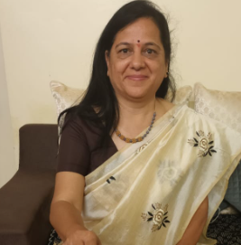

Ms. Ujjwala Sakhalkar

Assistant Professor

LL.M (PursuingPh.D.)

Email: [ujjwalasakhalkar@yahoo.co.in](mailto:ujjwalasakhalkar@yahoo.co.in)

Mob: 8484859916

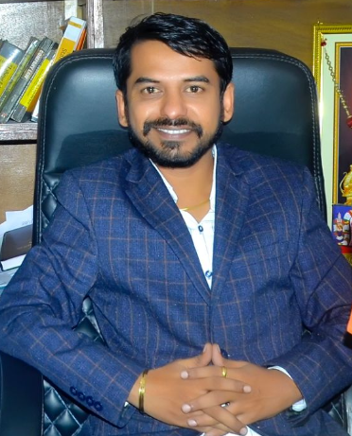

Dr. Rohit H. Surawase

Assistant Professor

LL.M, Ph.D.

Email: rohit.surwase-ext@bharatividyapeeth.edu

Mob: 9766620314

Bharati Vidyapeeth (deemed to be niversity) New Law College, Pune

Center for Community Development through Law (CCDL) STUDENT STEERING COMMITTEE

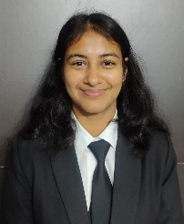 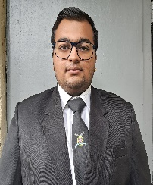  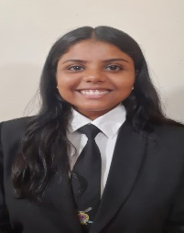

**KRITI AGRAWAL MR. MOKSH SANKHLA MR. SURAJ KUMAR Ms. ANUSHKA SHRIVASTAVA**

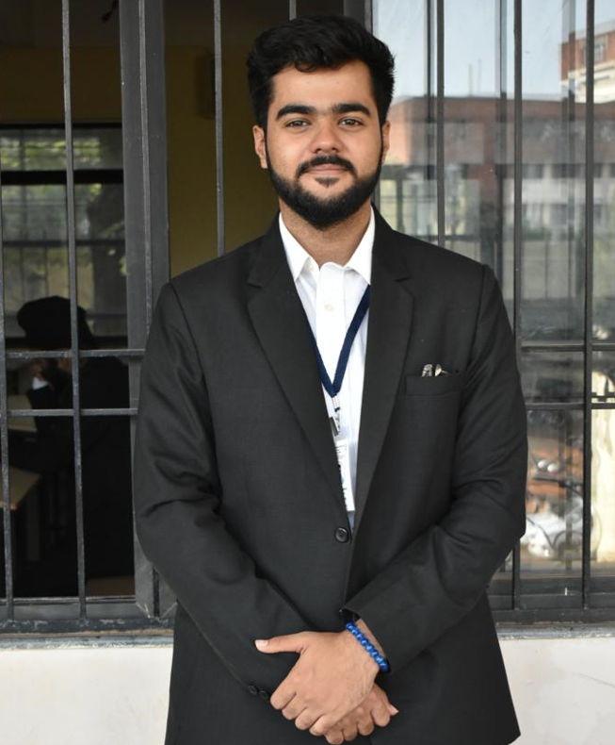  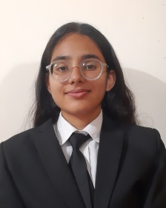

**MR. AKSHAT GANGWANI MR. VAIBHAV SINGH Ms. SHAILEY**